**Cloud based Attendance Management and Information System**

**A COURSE PROJECT REPORT**

**By**

**SAUNDARYA VERMA (RA2011031010091)**

**LARAIB HANIF (RA2011031010088)**

Shubh Govani, Darshit Solia, Dr. S. Thenmalar

Department of Networking and Communications,

SRM Institute of Science and Technology, Chennai – 603 203

# Abstract: -This dissertation is on the development of a cloud-based attendance management and information system. This work comes as a solution to the challenges of time theft and error prone attendance data analysis faced by using the manual method. The system has features like staff overtime calculation, staff/student attendance percentage calculation, meal orders, information dissemination through SMS and email which contributes to its uniqueness. The work is made up of two sections; the Hardware subsystem and Software subsystem. The hardware section involves collection and transmission of attendance data via the use of a Radio frequency identification tag reader and tag, interfaced with an ESP-12E Node microcontroller unit. The software section incorporates the design and development of a transaction processing and management information system which would handle the processing, analysis and storage of attendance data received from the hardware section via Hypertext transfer protocol (HTTP) requests. All the modules developed, were tested and attendance data analysis was carried out to ensure that the system met all the requirements.

Keywords: Cloud computing, Attendance management system, Radio frequency identification, Information system, overtime.

1. **INTRODUCTION**

The current manual attendance management systems used in schools in most developing nations like Nigeria has proven to be very inefficient. Students are made to fill in their names, registration number and signature. Most times, it is difficult to spot out students who are absent from lectures because their friends who must have learnt their signature sign for them. The lecturers are also faced with the challenges of manually reviewing the attendance. The same goes with staff attendance management as regards to their performance checks, reprisal and rewards. Another annual systems of attendance gathering usually rely on paper cards which have times stamped onto them using a time stamping machine. Another method is the use of timesheets or attendance registers. Manual system of attendance gathering widely used in schools and organizations till date.

An Attendance management system is therefore necessary for effectively monitoring and tracking of students’ attendance (Walia and Jain, 2016) and the time employees resume and close work. It is very important as it ensures proper monitoring of students attendance to classes and employees’ working hours with the goal of checkmating lateness, absenteeism as well as early departures. It helps eliminate time theft and over-payments thereby cutting down labor costs. In schools, students’ attendance data is used to guide the school authorities about a students’ attitude towards academic activities. Student attendance management in schools and colleges plays an important role in the improvement of student’s grade, learning efficiency and quality of education.

Hence the need for an attendance management and information system to help improve school administration (Zhang et al, 2013). Absence of a student from school affects a student’s learning outcome even if the absence is excused. The data from attendance can be used by these systems to identify students who may be at risk of dropping out of school, this system enables schools to come up with intervention schemes before problems develops. In organizations where productivity is very vital, attendance is used as a tool to determine employee attitude towards work. This serves as a great source of data that would enable management make useful informed decisions about their business.

# RELATED WORK

Recent trends in technology has greatly improved the efficiency of information systems (SunehraandGoud ,2016;Sayanekar et al, 2016). The current trends in technology have led to the development of better attendance management systems.

* Rasika et al (2016) proposed a biometric attendance management system that makes use of a fingerprint acquisition module and an attendance module resident on a personal computer configured with a Zigbee module which operates as the transmitter and receiver node. The system will help prevent proxy attendance.
* Jijankar et al (2017) developed an RFID based attendance management system. The authors in (Arulogun et al, 2013) made use of Radio frequency identification in the attendance management system proposed in their work. Their system was designed using Intersoft RFID demo kit-1, which makes use of a TR-RO1-DEM reader board that takes care of reading the RFID tags. Their application was designed to also help parents and institutions monitor truancy.
* Muhammad and Syed, (2016) proposed a cloud based Radio frequency identification attendance management system that would store attendance data remotely on a cloud hosted database. In their research they made use of Rapid application development methodology (RAD) to enable a working prototype of their system to be available within the shortest possible time.
* The authors in (Oo et al, 2018) worked on a cloud-based employee attendance management system using NFC technology. Their application provides several important operations such as captured attendance records using NFC, automatic time calculation, leave and overtime checking, work hours evaluation, real-time updated information access, and generating reports.
* Yadav and Bhole (2019) developed a prototype of a cloud-based end-to-end Smart Attendance System to solve the problems of manual attendance system prevalent in school and colleges by performing automated attendance record generation, reporting, monitoring and alert generation for different stakeholders of the educational institute.
* A Smart Attendance Management System (SAMS) that made use of advanced technologies of the IoT (Internet of Things), such as mobility, wireless network, fingerprint sensor and cloud computing was presented in (Sittampalam and Ratnarajah, 2019). The system records daily attendance of International Journal of Engineering Research & Technology (IJERT) http://www.ijert.org ISSN: 2278-0181 IJERTV10IS090051 (This work is licensed under a Creative Commons Attribution 4.0 International License.) Published by : www.ijert.org Vol. 10 Issue 09, September-2021 779 students in lecture halls and to provide web services for academic staff to manage and maintain attendance.
* Mane et al (2021) proposed a compact device as a solution to attendance management in schools that sends data to google sheets which most of the teachers are familiar with. Attendance percentages are calculated and the defaulters are sent mails periodically.
* Dhandapani et al (2021) proposed a system that uses text recognition to scan the identity (ID) card and verify student’s information and facial recognition is used based on demand to identify the person that signed the attendance. The automated attendance management and information system proposed in this work will be used to capture the attendance data of employees, lecturers and students and effectively sort the data into useful information sets which can be used by management for decision making and planning.

# SYSTEM OVERVIEW

The system development is segmented into three. These include: the development of a hardware module for attendance gathering using Radio frequency identification (RFID) reader and tags interfaced with an ESP-12E Node microcontroller unit;

the development of software program that would run on the ESP-12E Node microcontroller to process tag ID’s obtained from the radio frequency identification reader and sent via Hypertext transfer protocol (HTTP) requests to a cloud based management information system application and the Design of a transaction processing and management information system application to receive and process the RFID tag or card data sent via HTTP request and stored in a database for easy and accurate report

generations.

The software that would enable RFID card data obtained via the Radio frequency identification (RFID) reader to be sent via HTTP requests to a cloud based management system application, was designed to run on the ESP-12E Node microcontroller using the C/C++ programming language. The Arduino integrated development environment was used to upload the necessary software program to the microcontroller unit. The software was designed to interface with the in-built WIFI capability of the ESP-12E Node microcontroller unit to connect to a hotspot access point to enable communication with the cloud based Management

information system via HTTP requests.

The management information system (MIS) was developed to receive the data sent from the microcontroller module via

HTTP request connection to the remote web server process and stores the data in a database. The database used is the MYSQL relational database management system.

The MIS was deployed using a secure public cloud and its graphical user interface was developed using Hypertext Mark-up language, Cascading style sheets, JavaScript Programming language and controlled by a backend system built with Hypertext preprocessor (PHP), using the object oriented methodology (OOP). Application programming interface (API) was integrated into

the software to aid SMS messaging and reports generation in PDF format.

1. **TECHNOLOGY**

* Cloud computing
* mysql
* RFID

Radio Frequency Identification (RFID) is a technology based on wireless communication and Non-Line of Sight (NLOS) to retrieve information. Radio wave concept in RFID is able to collect information from the transponder (tag) to RFID reader, with advantages of this technology and more convenience for student attendance system thus apply in this system.

1. **IMPLEMENTATION**

A. Hardware Systems Design

The hardware system for this project comprises of the following components, ESP-12E NODE MCU and MFRC522 Radio frequency identification reader which were interconnected and is to be used with MFRC522 compatible Tags as shown in fig.1 Figure1: ESP-12E Node Mcu and Mfrc522 Hardware connection. Software was developed for the Esp-12E Node microcontroller unit to properly communicate with the Mfrc522 RFID reader for attendance data to be captured and sent to the cloud based management information system. The Node Mcu was connected to the computer via Universal serial bus (USB) cable from where the communication software was installed on it.

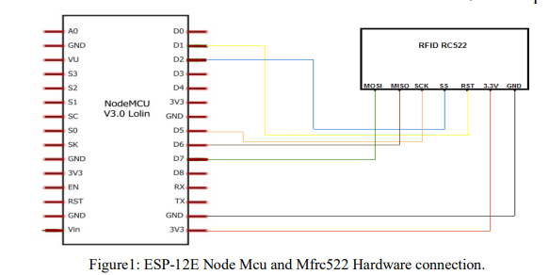

B. Software Design

The attendance management and information system software was designed using the object oriented programming software design methodology because it aids code reusability, ease of software maintenance and software refactoring or reengineering.

The graphical user interface were developed using Hypertext Mark-up language (HTML), cascading style sheets (CSS), JavaScript programming language. The graphical user interface is the medium through which users of the cloud based management information system would interact with its functionalities by the use of forms, tables, and buttons.

Since the cloud based attendance management system is a combination of a transaction processing and management information system a backend for the processing of MFRC522 RFID card unique ID received from the ESP-12E Node microcontroller unit via HTTP request was developed using Hypertext preprocessor (PHP) for efficient processing. The interaction of staff and students with the RFID hardware module would generate a lot of data that wassent via HTTP requests to the attendance management and information system hosted on a web server.

The data generated needs to be stored securely and efficiently after processing, for this to be achieved MYSQL relational database management system which offers high performance, high availability, scalability and flexibility, strong data protection, good transactional support and very low cost of ownership was developed.

The low cost of ownership makes it ideal for making this system very cost effective. A relational database aids data relationship using tables as a medium of data storage. Keys called primary and foreign keys are used to achieve data relationship between tables. The language used to interact with the MYSQL relational database management system is the structured query language (SQL).

The database to support all modules and functions of the attendance management and information system was designed to ensure efficient and fast data query and retrieval, eliminate data redundancy, and ensure ease of maintenance and scalability while maintaining proper relationships between tables that exist within the database.

The software modules developed include: Registration module; Login module; Attendance marking module; Tag assignment module; Information dissemination module; Meal Ordering Module; Course Registration Module; Timetable Module and Attendance Analysis Module The attendance marking module is responsible for ensuring that all attendance of registered staff and student is marked accurately.

The module receives data via Hyper Text Transfer Protocol (HTTP) request which are sent from the hardware attendance data gathering unit made up of the ESP -12E Node MCU and RFID reader and tags. The card unique identification obtained is carefully processed and stored against the correct user using this module. The flow chart for this process is given in fig.2

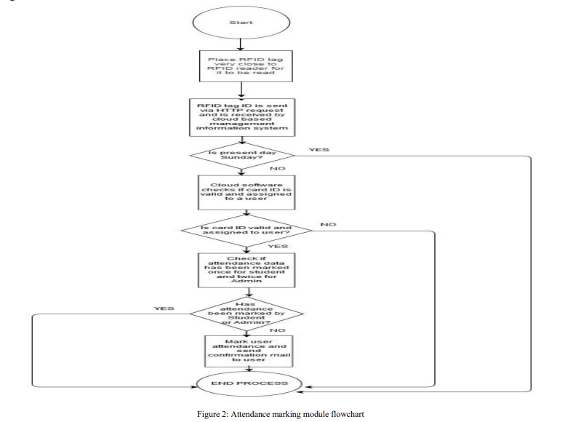

This module receives card ID data, and secrete key, checks if the secrete key is valid, cleans up the data using a card ID sanitization function, then searches the database to see if the card ID is valid and assigned to a user, if it is assigned it searches the database to check if the card ID already been set to present for the current date.

If it is not, it is then set to present and a mail wassent to the email of the user whom the tag is assigned to. The radio frequency Identification Tag assignment module handles the process of assigning RFID tags to staffs and students. The process of RFID tag assignment would be done solely by an Admin.

The flow chart for this process is shown in fig.3

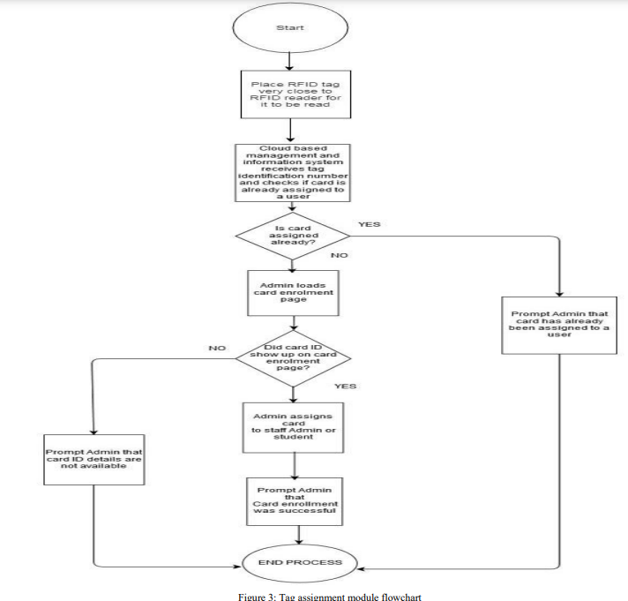

* The first step is to place the card at a close distance of the RFID reader and then open up the management information system cloud based application, then navigate to card enrolment page. The card ID of the tag would be available for enrolment. The Admin would then assign the tag to a student or staff that has not yet been assigned a tag. All the relevant information would be stored in the database.Information dissemination module handles the dissemination of relevant information to both staff and students. The information is sent via email or Short message service (SMS) depending on the admins preference. The information to be sent is filled in a form and the kind of messaging channel to use for message dissemination is selected in the form also and this message is sent to all users under the selected category. Email and SMS API’s was developed and used for this process.
* The Meal Ordering module would help solve the problem of food ordering in the center used as a case study which is currently very slow and counterproductive. This module helps control wastage, because meals would be ordered by only staff and students whose attendance has been marked for a particular day. The information about the meal orders is to b eprovided by each individual user. All meal orders should be placed by all users before the preset time that was set for the order to be sent. The preset time for meal order in this work is 11AM. Once the meal orders are placed by individual users, all the orders would be sent via Email and SMS to the food vendor programmatically at the exact preset time for placing meal orders.
* Course Registration Module handles all aspects of course registration depending on the program, duration, credit load and session to be taught. Every time a new course is to be registered it would be stored in the database with all the relevant information such as Course name, Credit load, Course Code, Session to be taught and Course description. The unique identifier for each course is its course code. The course registration would be done via a course registration form that would be accessible to staff only.

Attendance Analysis Module performs analysis on the attendance data stored in the Mysql relational database management system and produces useful reports in the form of Bar charts on the attendance history of both staff and students and these outputs can be downloaded in PDF format. It consists of other sub-modules like the staff attendance analysis module that handles all staff attendance analysis. It is used to generate PDF reports of staff attendance history and hours worked per day/week/month. It also caters for the overall staff attendance computation for the total percentage duration of hours work per day/week/month. The flow chart for this module is shown in fig.4

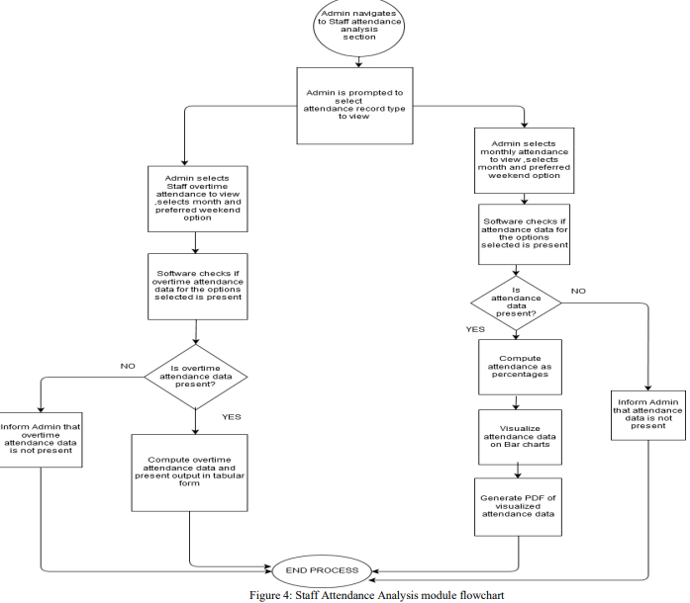

The staff attendance analysis module programmatically tracks all cases of staff overtime worked per month and gives a clear duration of the amount of overtime a staff has worked. The overtime analysis can be visualized tabular form which gives very clear and precise information of overtime worked for any given month.

C. Software Security

Security is very vital to long term usage of any software system, the attendance management and information system utilized very efficient and secure cryptographic hashing algorithms to hide the actual value of very sensitive data. The cryptographic algorithms used is a combination of the MD5 and Blowfish hashing algorithms. The MD5 algorithm known as message digest algorithm is a one way data encryption algorithm which produces a 32 character long hexadecimal hash which has a size of 128- bits. The blowfish algorithm is an algorithm used to encrypt data in order to prevent it from being readable to the human eyes; it is a very fast keyed, symmetric cryptographic block cipher.

1. **RESULT AND DISCUSSION**

The hardware and software components of the cloud based attendance management and information system were developed based on the requirements of this system. This system is meant to improve the attendance collection and analyses method at the Centre for information and Telecommunication. All the modules programmed using JavaScript and tested thoroughly to ensure strict compliance with the project requirements. To test all the functionalities of the platform, attendance data was generated for a total number of twenty individuals from January through November of 2018. Sample graphical user interfaces for the developed application is shown in fig.5 and fig.6. Fig.7 is the graphical display of the output of the staff analysis module.

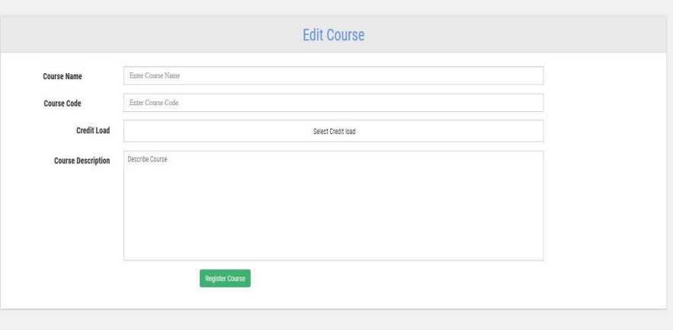

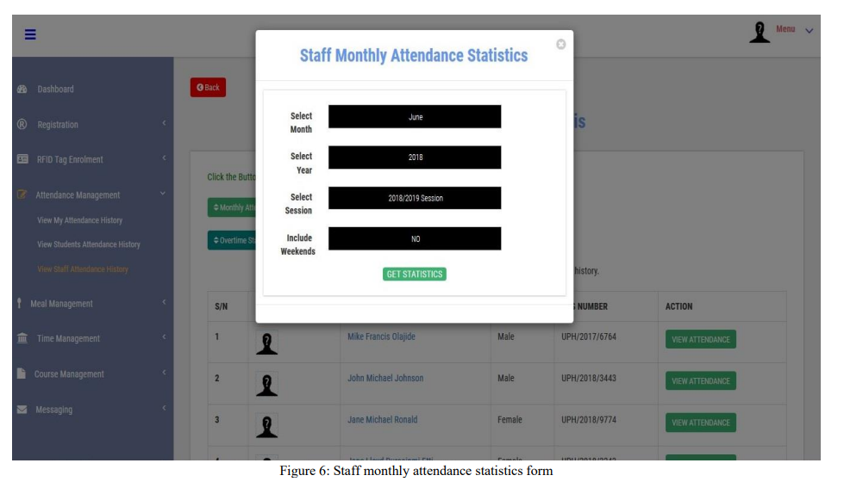

# CONCLUSION

Attendance management and information system for attendance gathering and processing is a necessity for schools and organizations, because it helps save funds and eliminates time theft by employees, and buddy punching which are the order of the day with manual methods of attendance gathering. This work focused on the development of a cloud based attendance management and information system using the Centre for Information and Telecommunication Engineering, University of Port Harcourt as a case study. Attendance data gathering from both staff and student was made possible via the use of radio frequency identification tag reader and tag. The data obtained from the tags were sent to a cloud based information system application which processed, and stored the data received. The system also generated reports about student/staff attendance performance for a given month/year, student course attendance performance report for a given course and staff overtime performance report for a given month. This staff overtime performance report is very useful during payroll preparation, since it would be very easy and less time consuming for the accounts department to ascertain which staff actually had overtime hours. The cloud based Attendance Management and Information System would save funds, improve productivity and aid better administration by providing an efficient tool that receives data, processes it and generates accurate attendance reports in a fast and timely manner.

# REFERENCES

[1] Arulogun, O.; Olatunbosun, A.; Fakolujo O. A. and Olaniyi, O.M. (2013). RFID-Based Students Attendance Management System. International Journal

of Engineering and Scientific Research, 4(2): 1-9, https://www.researchgate.net/publication/235598499_RFIDBased_Students_Attendance_Management_System

[2] Dhandapani V., Majji S., Udata K., Manigandan M. (2021) Implementation of Attendance Management System Based on Text and Face

Recognition. In: Bansal R.C., Agarwal A., Jadoun V.K. (eds) Advances in Energy Technology. Lecture Notes in Electrical Engine ering, vol 766.

Springer, Singapore. https://doi.org/10.1007/978-981-16-1476-7_7

[3] Sittampalam, G. and Ratnarajah N. (2019). SAMS: An IoT Solution for Attendance Management in Universities. TENCON 2019 - 2019 IEEE Region

10 Conference (TENCON), India. DOI: 10.1109/TENCON.2019.8929616.

[4] Jijankar, S.; Dhore, A.; Sanganwar, A.; Chalkhure, K. and Parihar, V.R. (2017). RFID Based Student Attendance Management System : A Review and

an Approach. International Advanced Research Journal in Science, Engineering and Technology, 4(9): 262–65.

https://iarjset.com/upload/2017/september-17/IARJSET%2036.pdf

[5] Mane, A.; Autkar, T.; Pimple, C.; Sonkusare, R. and Weakey, S. (2021). Fingerprint Based Attendance Management System. Proceedings of the

International Conference on Innovative Computing & Communication (ICICC) 2021.

https://ssrn.com/abstract=3832700 or http://dx.doi.org/10.2139/ssrn.3832700

[6] Muhammad. F, and Syed. Z (2016). Cloud-based RFID Attendance System. UTM Computing Proceedings: Innovations in Computing Technology and

Application, 1. https://engineering.utm.my/computing/proceeding/wp-content/uploads/sites/114/2018/04/Cloud-based-RFID-Attendance-Sys**tem.pdf**